34.97: At the first surface, 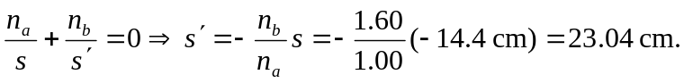
At the second surface, 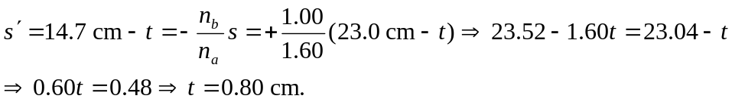
(Note, as many significant figures as possible should be kept during the calculation, since numbers comparable in size are subtracted.)

